All-cause Mortality

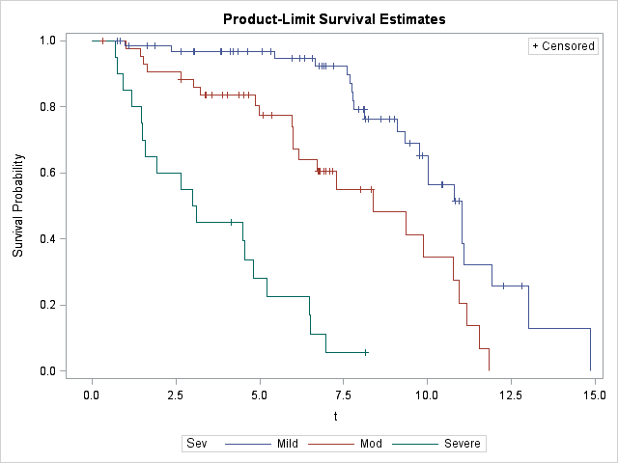

Figure 1. Kaplan-Meier survival curves illustrating survival times from initial diagnosis for all-cause mortality in 129 dogs diagnosed with SAS with available follow-up. Mild was defined as PG < 50 mmHg; moderate as PG between 50 and 130 mmHg; and severe as PG > 130 mmHg. All curves are statistically different from one another (p < 0.001).